**Python/Pyomo/CPLEX/CBC/Solver Studio Installation:**

By:

LCDR Connor McLemore

Dr. Michael Atkinson

CAPT Ezra Akin

Install Python:

Run Python 3.X Installer at

<https://www.python.org/downloads/>

Note: when asked, check box to add Python 3X to PATH

Then update the Path for Python:

Path in Search > Edit the system environmental variables > Advanced > Environmental Variables > Path (In System Variable, not User Variables) > Edit > add the path to Python 3.X

ex. C:\Users\Connor\AppData\Local\Programs\Python\Python35-32\Scripts

Note: Delete any paths to old versions of Python

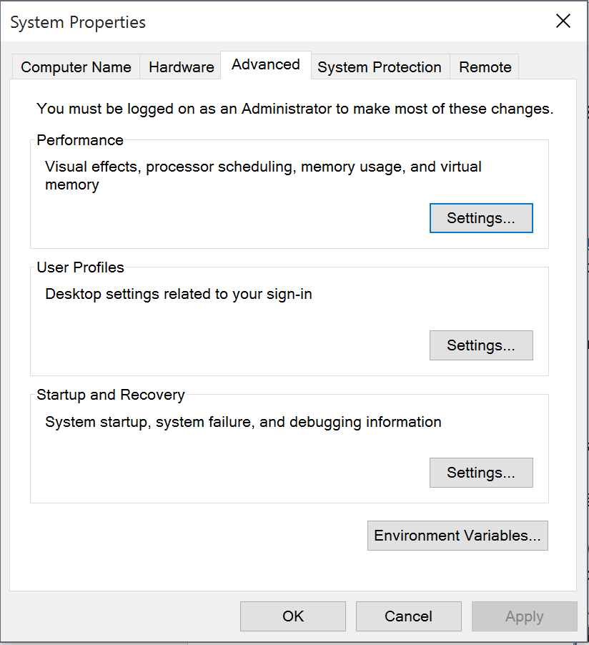

Uninstall Old Pyomo (not necessary if Pyomo never previously installed):

From CMD Line:

cd C:\Users\Name (ex. Connor)

pip uninstall pyomo ‘note: pip is scientific python, a separate python package required for pyomo

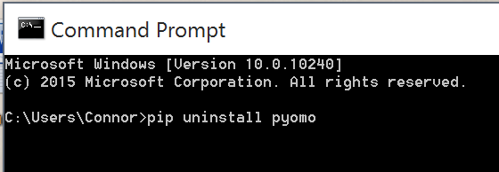

Figure 2. CMD line inputs to uninstall old version of pyomo

Download and Install New PIP (Scientific Python) and Pyomo:

Download PIP file (right click, save get-pip.py file to downloads folder) at

<https://pip.pypa.io/en/stable/installing/>

Open CMD line, > cd downloads > python get-pip.py

Note: When opening the CMD prompt, right click on it and select “Run as Administrator” when installing PIP and pyomo

Install Pyomo:

Pyomo comes with PIP now. Once PIP is installed, from the command line type:

pip install pyomo

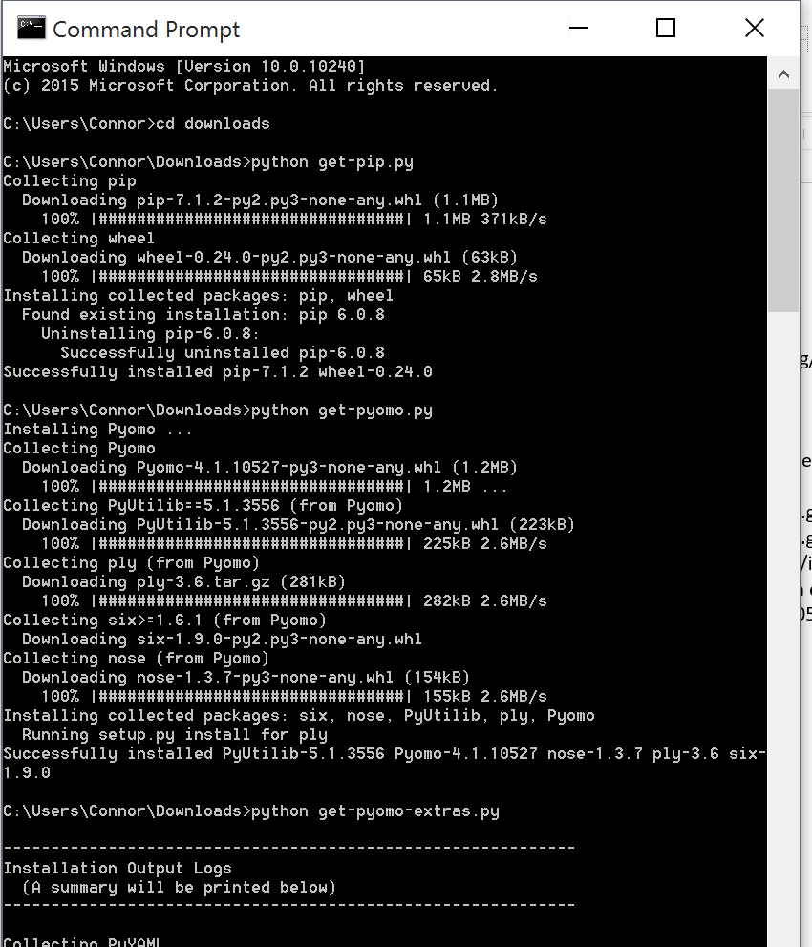

Figure 3. CMD line pip and pyomo install

To Run Pyomo model from the command line:

Go to the location of the pyomo model and data file

Within the Solver Studio Model Window in Excel: File > View Working Files, copy the folder address > open CMD > in CMD line: cd + space + copied address

Example: cd C:\Users\Connor\AppData\Local\Temp\SolverStudio sgcrolqa

> pyomo model.py SheetData.dat --solver=cbc

Note: if successful, results.yml file is created and placed in the same folder with the results of the pyomo run

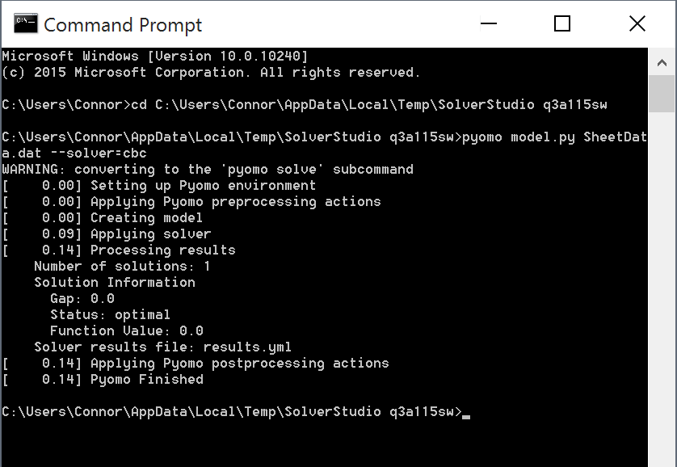

Figure 4. Pyomo run from CMD line

Adding Solvers:

CBC and some other solver executables come with solver studio and are available in the solver studio solvers folder. Copy any solver files you will run from the command line in a folder somewhere on the C drive. If their existing folder is on the C drive already, you don’t need to change it.

Update the Path for the Solver exe:

Note: some solvers will add the path automatically when they are installed

Note: CPLEX does. It can be downloaded by googling “ibm cplex student download” with a .edu email. You will have to register with IBM for an account.

Path in Search > Edit the system environmental variables > Advanced > Environmental Variables > Path (In System Variables or User Variables) > Edit > add the path to solver exe file

ex. C:\Users\csmclemore\AppData\Local\Programs\Solvers

Note: Folders from the shared desktop in parallels won’t work, put the folder in the C drive somewhere!

Test by opening CMD line, type the solver name ex. cbc



Figure 5. cbc solver working per the above instructions



Figure 6. cplex solver working per the above instructions

Internet-Free Pyomo Install:

Download Pyomo (in advance)

At <https://software.sandia.gov/trac/pyomo/downloader>

Download Pyomo version pyomo_4.0.9682.zip ‘note: don’t unzip

Download Pyomo Installer version pyomo_install ‘note: right click and save as default on link

to the Downloads folder

Note: need to provide some info to Sandia to do this

Install Pyomo

Open command line, type cmd into windows search bar, type the following in the cmd line:

cd downloads

python pyomo_install --zip=pyomo_4.0.9682.zip ‘note, use <- version

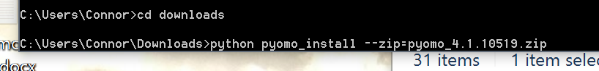

Figure 6. CMD line inputs to install pyomo